VA-10J基本情報

# 仕様

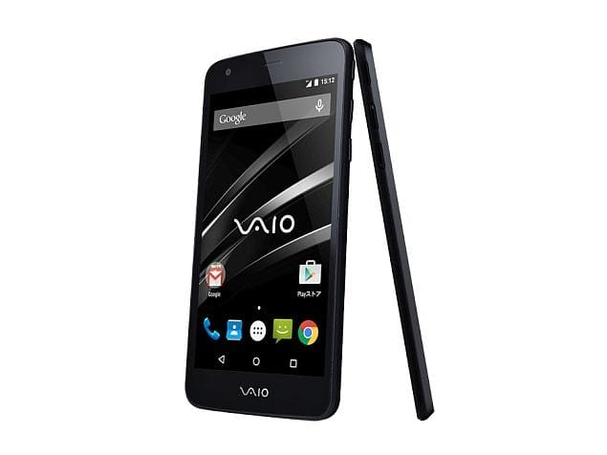

Vaio Phone (VA-10J) smartphone was launched in March 2015. The phone comes with a 5.00-inch touchscreen display with a resolution of 720 pixels by 1280 pixels.

The Vaio Phone (VA-10J) is powered by 1.2GHz quad-core processor and it comes with 2GB of RAM. The phone packs 16GB of internal storage that can be expanded up to 64GB via a microSD card. As far as the cameras are concerned, the Vaio Phone (VA-10J) packs a 13-megapixel primary camera on the rear and a 5-megapixel front shooter for selfies.

The Vaio Phone (VA-10J) runs Android 5.0 and is powered by a 2500mAh non removable battery. It measures 141.50 x 71.30 x 7.95 (height x width x thickness) and weighs 130.00 grams.

The Vaio Phone (VA-10J) is a single SIM (GSM) smartphone that accepts a Micro-SIM. Connectivity options include Wi-Fi, GPS, Bluetooth and 3G. Sensors on the phone include Proximity sensor, Accelerometer, Ambient light sensor and Gyroscope.

**About Vaio**

Vaio was originally the laptop unit of Sony. Now, the investment firm Japan Industrial Partners owns the brand. The company has launched Android smartphones. The company's Android smartphones run Android 5.0 Lollipop. It uses Japan Communications' sales channels to sell its smartphones.

### [Vaio Phone (VA-10J)](https://gadgets.ndtv.com/vaio-phone-va-10j-2503)

* **KEY SPECS**

Display**5.00-inch**

Processor**1.2GHz quad-core**

Front Camera**5-megapixel**

Resolution**720x1280 pixels**

RAM**2GB**

OS**Android 5.0**

Storage**16GB**

Rear Camera**13-megapixel**

Battery Capacity**2500mAh**

Compare Vaio Phone (VA-10J) With :

### Vaio Phone (VA-10J) full specifications

#### **GENERAL**

| Release date | **March 2015** |
| --- | --- |
| Form factor | **Touchscreen** |
| Dimensions (mm) | **141.50 x 71.30 x 7.95** |
| Weight (g) | **130.00** |
| Battery capacity (mAh) | **2500** |
| Removable battery | **No** |
| Colours | **Black** |

#### **DISPLAY**

| Screen size (inches) | **5.00** |
| --- | --- |
| Touchscreen | **Yes** |
| Resolution | **720x1280 pixels** |

#### **HARDWARE**

| Processor | **1.2GHz quad-core** |
| --- | --- |
| Processor make | **Qualcomm Snapdragon 410** |
| RAM | **2GB** |
| Internal storage | **16GB** |
| Expandable storage | **Yes** |
| Expandable storage type | **microSD** |
| Expandable storage up to (GB) | **64** |

#### **CAMERA**

| Rear camera | **13-megapixel** |
| --- | --- |
| Rear flash | **LED** |
| Front camera | **5-megapixel** |

#### **SOFTWARE**

| Operating system | **Android 5.0** |
| --- | --- |

#### **CONNECTIVITY**

| Wi-Fi | **Yes** |
| --- | --- |
| GPS | **Yes** |
| Bluetooth | **Yes** |
| NFC | **No** |
| Infrared | **No** |
| USB OTG | **No** |
| Headphones | **3.5mm** |
| FM | **No** |
| Number of SIMs | **1** |
| **SIM 1** |  |
| SIM Type | **Micro-SIM** |
| GSM/CDMA | **GSM** |
| 3G | **Yes** |
| 4G/ LTE | **No** |
| Supports 4G in India (Band 40) | **No** |

#### **SENSORS**

| Compass/ Magnetometer | **No** |
| --- | --- |
| Proximity sensor | **Yes** |
| Accelerometer | **Yes** |
| Ambient light sensor | **Yes** |
| Gyroscope | **Yes** |
| Barometer | **No** |
| Temperature sensor | **No** |

# 領収書

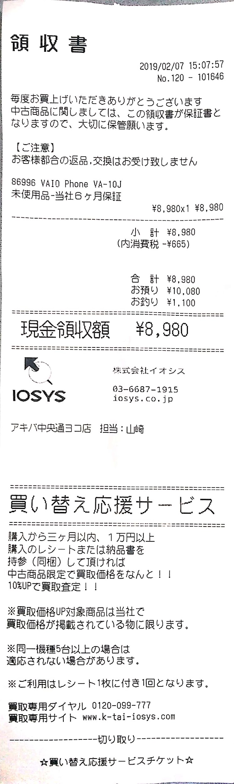

# シリアルナンバー

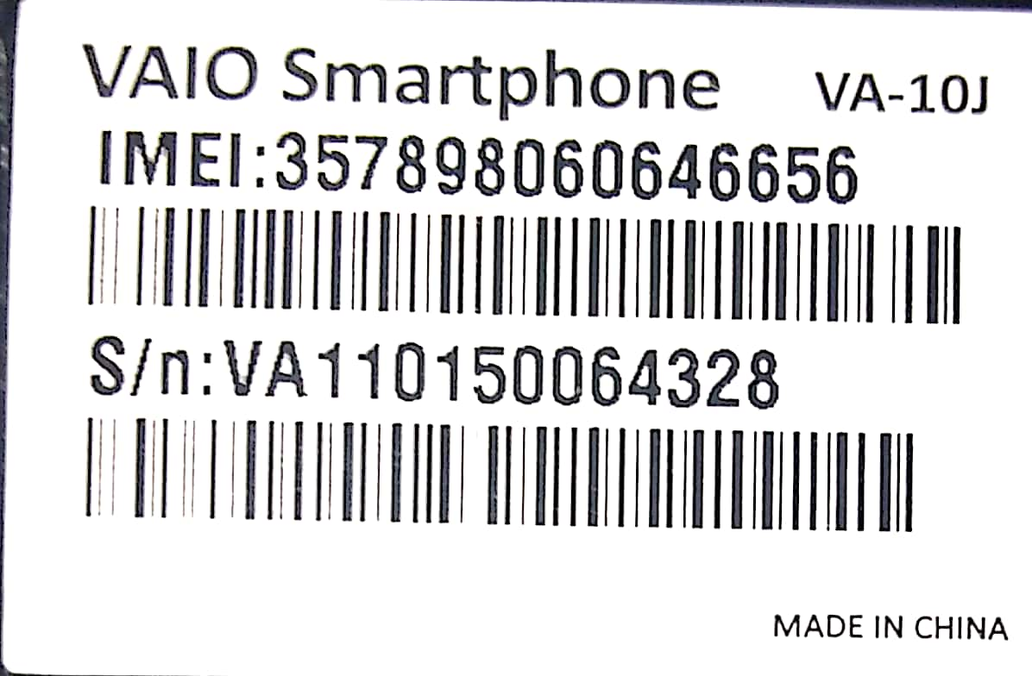

# 端末情報

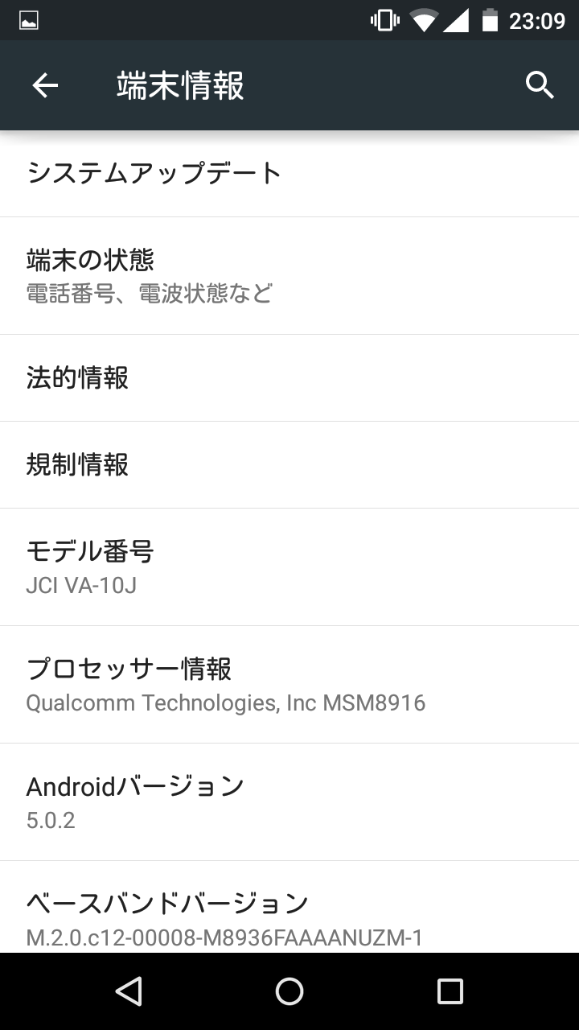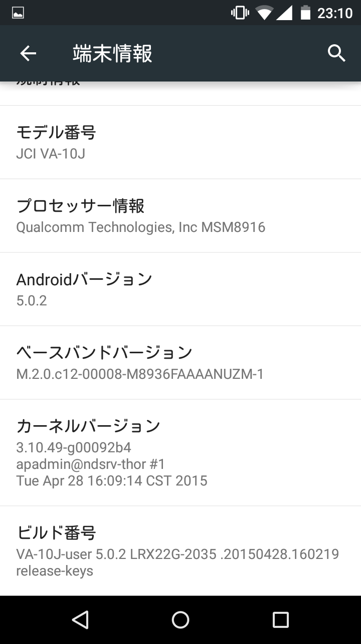

# 端末の状態

